# BACKGROUNG STUDY

Online stores form part of the electronic commerce and the digital market. With a large growth in e-commerce made possible by the rise and growth of the internet it forms a great deal of peoples live around the world. Creating convenience and accessibility to almost anything imaginable there will always be a need and want for more and better online systems making it even easier and simpler to order and buy products online. With e-commerce many barriers have been brought down in the political and physical manner creating the opportunities for more and more people to have an equal opportunity within the markets of business.

As seen below in figure 1 the current statistics regarding ecommerce showing the great global revenue it creates giving an indication of the need and importance of online shopping.

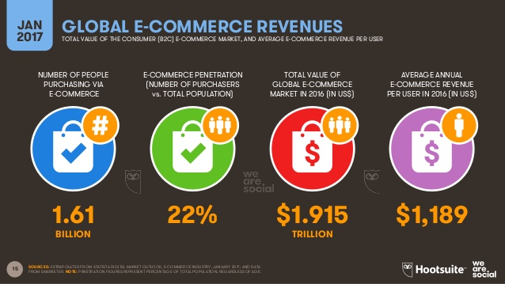

Figure 1

Figure 2 is the MasterCard online behavioural study based on South Africa. As seen in the figure the percentages of MasterCard card holders a large percentage of users use online shopping.

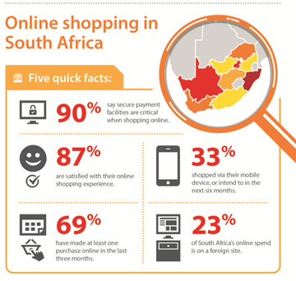

Figure 2

# Summary

## Cloud Services

In this phase of the project, we will implement cloud services. These services will be used to enhance the experience. These cloud services will primarily be used to store user information and payment details in a secure location and facilitate the payment process. Secondly, we will integrate cloud services to add an element of social media to the application, allowing user to keep up with their desired trends and set preferences for the items they are interested in. This will also be the cornerstone technology behind token sharing and purchasing.